2.5.6

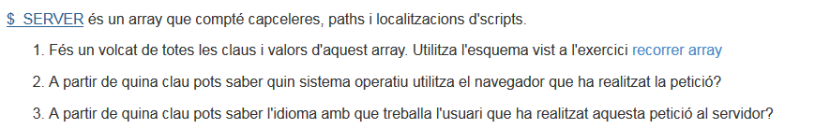
1. foreach( $_SERVER as $clau=>$valor) {
echo "El valor de [$clau] és [$valor] <br>";
}

- print( $_SERVER["HTTP_USER_AGENT"]);
- print( $_SERVER["HTTP_ACCEPT_LANGUAGE"]);

